Run 1
Train with 5000

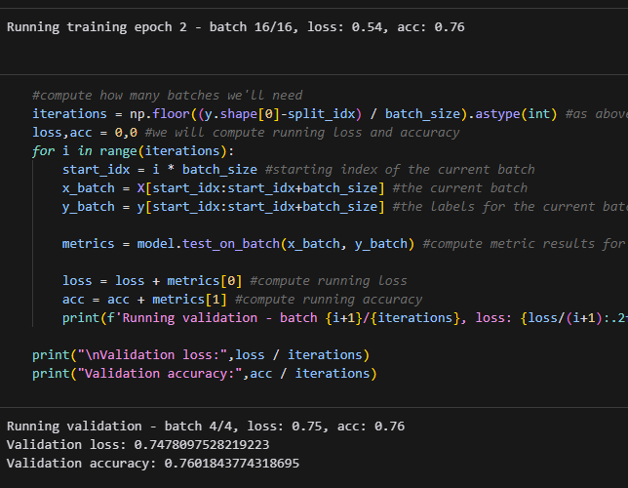

Run 2
Train with 20000

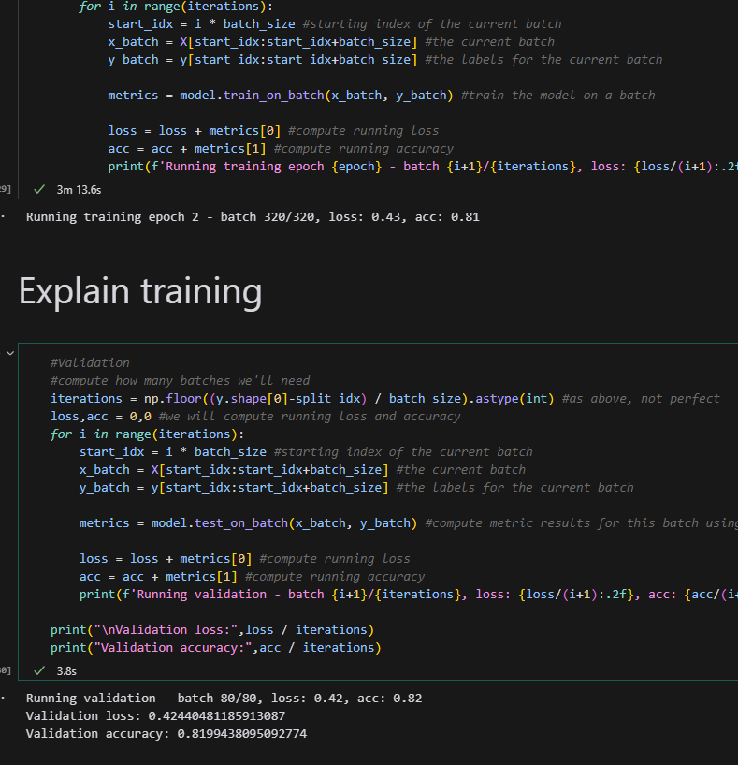

After Trial one I solved for some errors and improved some overall efficiency. Also fixed where I was reading in test AND train and combining them. WOW
I then added some multithread processing boosts and experimented with ways to use tensorflow-gpu.
After Trial two I went through and cleaned up my libraries. I researched more methods of improving and found ther importance of normalization. I also improved my neural model structure by updating its construction to newer methods. I then improved my reporting methods. Increased batch size

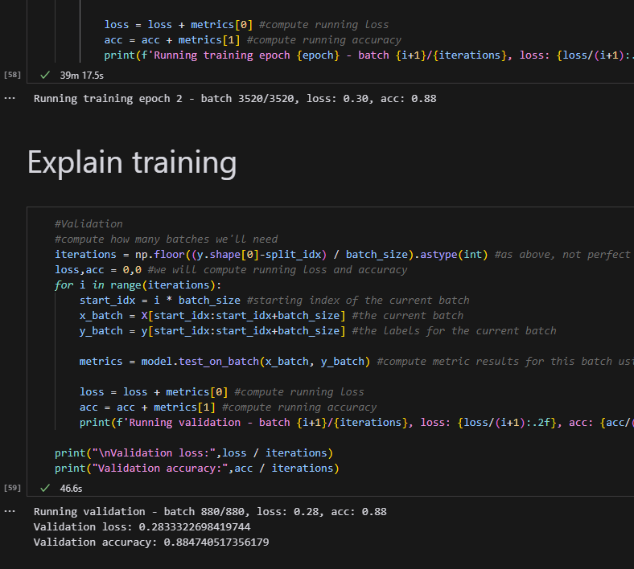

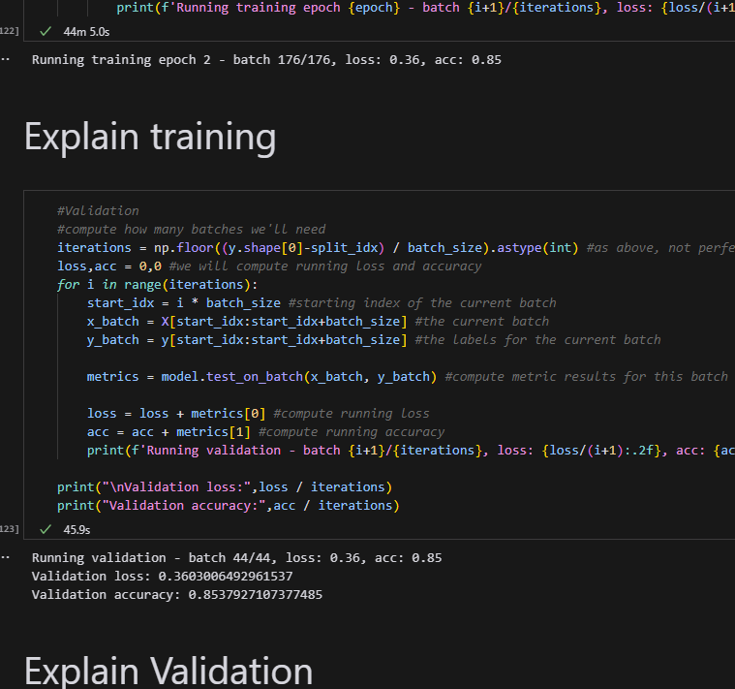

Tried to run for a submission. Encountered error pointing to corrupted file. Set logic to deal and proceed. Also discovered how to save models. Added line for that.

